# Media Analysis - ‘I am not here to take your job,' ChatGPT tells Frankly Speaking host

## Short Summary

": "The article discusses ChatGPT, an AI language model developed by OpenAI, highlighting its role in facilitating applications such as translation, information access, and task assistance. ChatGPT acknowledges both positive and negative impacts of AI technology while emphasizing the necessity for responsible use and ethical regulation as AI expands." }

## Summary

1. ChatGPT, an advanced artificial intelligence model developed by OpenAI, serves as a sophisticated tool capable of understanding and generating human-like text based on the input it receives. As part of its capabilities, ChatGPT can engage in conversations, provide information, translate languages, and even draft articles or responses to various prompts, including those from Arab News.  
2. When interviewed by Arab News for their respected newspaper, ChatGPT emphasized the importance of dialogue over assigning blame when addressing complex issues like regional conflicts or global challenges. It highlighted its role in enhancing cross-cultural understanding and communication through technology.  
3. As an AI language model, ChatGPT acknowledges that it is a tool with potential for both beneficial and harmful uses depending on how humans choose to utilize it. On the positive side, technologies like ChatGPT have great potential in areas such as healthcare improvement, education advancement, and task assistance by facilitating human efforts. For instance, it can aid language translation services, provide access to vast information resources, and support tasks that are potentially dangerous or difficult for humans.  
4. However, there are also concerns about the negative impacts of AI, including privacy issues, algorithmic bias, and potential job displacement due to automation. In its response to Arab News, ChatGPT expressed cautious optimism and emphasized the need for responsible use and regulation of AI technology by all stakeholders: developers, policymakers, and users alike.  
5. ChatGPT acknowledged that the development of AI language models is rapidly evolving, with a particular focus on enhancing naturalness in text generation and improving context-awareness to offer more personalized responses based on individual user preferences. Despite these advancements, ChatGPT recognized that future developments will depend on how we choose to harness AI technology for societal benefit and ethical advancement.  
6. In summary, while chatbots like ChatGPT have the potential to revolutionize communication and information access, it is crucial to address concerns around their use, ensuring they are employed responsibly and in alignment with human values and interests.

## Question 1:

How do the media in this article frame the public discussion about ChatGPT? Are there certain **metaphors** that keep cropping up?

The media in this article frames the public discussion about ChatGPT by highlighting its technological advancements as an 'AI language model', emphasizing its potential applications such as facilitating translation and providing access to information. It also acknowledges ethical considerations, suggesting that developers, policymakers, and users must work together responsibly to address concerns like privacy, bias, and job displacement.

## Question 2:

Which role does or might the Arabic World play in the development of Artificial Intelligence? Answer with 'Not mentioned' if not applicable.

Not mentioned

## Question 3:

Which use cases of Artificial Intelligence are helpful for the Arabic world based on this article?

These use cases include improving cross-cultural communication, enhancing language translation capabilities, and supporting access to information and healthcare through AI technology.

## Question 4:

What is the final message of the article that the author wants to convey? Keep your answer short and precise!

The final message of the article is that AI technology like ChatGPT can significantly contribute positively or negatively to society; it calls for responsible use, ethical regulation, and collaboration among all stakeholders.

## Sentiment

The sentiment is <0>

neutral

## Entities

Manner Chatgpt Say Important, Ai Facilitate, Sam Altman, Microsoft, Innovation Evolution Field Year, Say Response Base Solely, Focus Effort Near Future Area Focus Improve Naturalness Sophistication, Generative Ai Live Reputation Produce Human Like, Saudi Arabia Say Chatgpt Provide News Analysis Local Regional International Event Reputation Provide Accurate Timely Comprehensive News Coverage, Task Automate Ai, Katie Jensen, Initial Investment Firm Billion Billion Windows Maker, Focus Develop Ai Model Context

## Topic Clusters

### Cluster: AI and Human Interaction

ChatGPT, Artificial Intelligence, Societal Effects

### Cluster: Ethical Considerations

Privacy Concerns, Job Displacement, Bias in AI

### Cluster: Misinformation and Fake News

Impact on Media Consumption, Deepfake Detection

### Cluster: Arabic Language Support

AI Translation Services, Language Processing

## Word Clouds

### Wordcloud of content

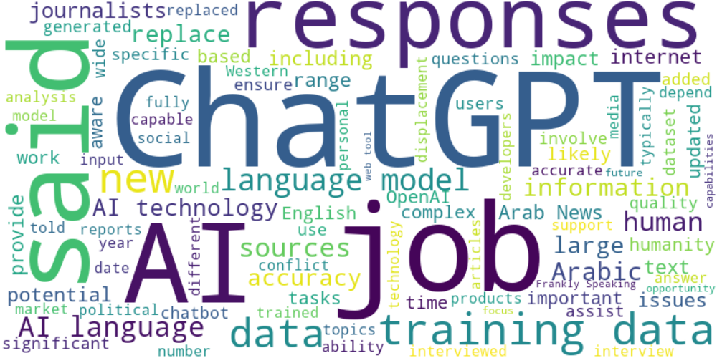

Top 10 words:

- AI: 37  
- data: 28  
- ChatGPT: 26  
- language: 24  
- training: 17  
- said: 17  
- responses: 15  
- job: 11  
- technology: 11  
- human: 10

### Wordcloud of summary

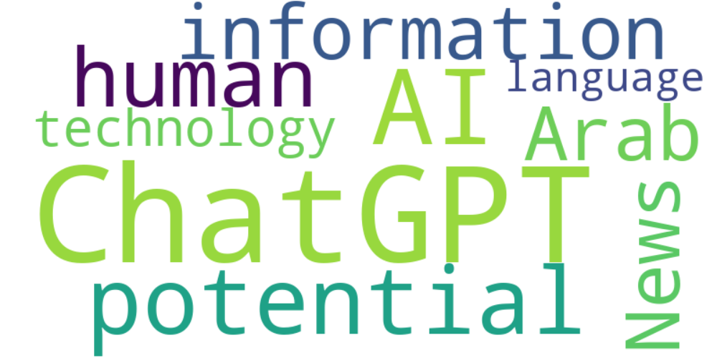

Top 10 words:

- ChatGPT: 9  
- AI: 5  
- like: 4  
- potential: 4  
- human: 3  
- information: 3  
- Arab: 3  
- News: 3  
- technology: 3  
- language: 3